Załącznik nr 2

METODYKA WARSZTATÓW do ZAPYTANIA OFERTOWEGO
nr GAPR-KETGATE/ 866 /18/W

dotyczące moderowania i przeprowadzenia warsztatów regionalnych dla przedstawicieli instytucji badawczo-rozwojowych świadczących usługi lub posiadających infrastrukturę w obszarze Key Enabling Technologies (KETs) w oparciu o metodykę zgodną z założeniami projektu KETGATE.

.
  - Regional Workshop with RTO
In order to collect the relevant information, PPs are asked to organise Regional Workshops with R & D units from the area of Key Enabling Technologies (KETs). Hereafter some suggestions and recommendations to better schedule and manage the workshops.

    - Aim of the workshop
The result of the workshops will be an assessment of the potential and challenges of R&D units participating in workshop from the area of Key Enabling Technologies (KETs).
Workshop is organized to adhere and exchange experience in KETs with follower RTOs participating in KETGATE project. The aim is also to promote the project and involve stakeholders into the project activities and to collect insights and information from the stakeholders in order to better organise and set up the network of smart KET access points.

    - Target group of the workshop
The suggestion is to have at least 5 different R & D units participating in workshop from the area of Key Enabling Technologies (KETs). The number of participants may be approx. 10-15 participants.

    - Format of the workshop
The best option is to organise an “interactive” event in order to catch participants’ views and gather rich inspirations from each regional innovation ecosystem. This is why it is suggested to organise a structured event with selected participants. The methodology recommended is the World Café (http://www.theworldcafe.com/). World Café has been selected since it is a simple but effective methodology to boost informal and fruitful conversation. It has also been tested as a technique to stimulate creativity and active participation.

    - The World Café methodology
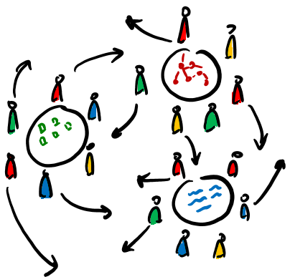
Informal meetings among people (like conversation started in coffeehouse, home sitting rooms or other places devoted to socialisation) have always been the frame for exchanging views, be active in the social life, learn together. The goal of World Café methodology is to simulate these social contexts to mobilize thoughts, share knowledge, foster change around a specific topic.
Here the main features:
- It is a half a day event (4 hours maximum);
- The environment should recreate the cosy and informal atmosphere of a coffeehouse (natural light, nice table-cloths, flowers...). You should have posters to remind participants the World Café etiquette (you can find some examples in the World Café website);
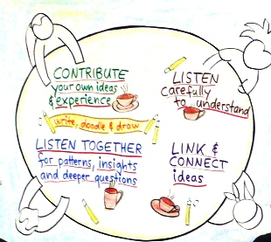
- 3 tables and group of chairs are set up for 4-6 people + facilitator for the different rounds. At each table there should be available post it, 1 big papers to collect all the insights, markers, material to take note, draw and note down ideas;
- Coffee station available for participants during all along the event (food and beverage easy to move on the tables);
- Each table should have a facilitator which takes the role of host. He/she has the role to stimulate all participants to express their view, to track the conversation and the ideas emerged, to sum up the outcomes of discussion to the following group to foster contamination and exchange among groups, to present in the final session the main points emerged.
- The process foresees one plenary session at the beginning to give participants the rules of the play, (3) small round of 20-30 min during which participants are asked to choose one table and answer to a question. After this time, participants have to move to another table and start again the discussion. At the end it is foreseen one plenary session to make the conclusions and ask participants’ feedbacks.
The selection of the question/s is really a key point. Questions should be simple and clear in order to start up the debate, invite to go deeper the topic, open the possibility to have different views and focalise the attention on the core issue. You can find more information: http://www.theworldcafe.com/key-concepts-resources/world-cafe-method/

